East Knox County Elementary School

*A proud Leader In Me school*

*Cougars C.A.R.E.*

**\****We* ***C****are about each other.* **\****We* ***A****lways problem solve.*

**\****We* ***R****ead and respond.* **\****We* ***E****ngage in learning and leading.*



Photo Credit: <http://bit.ly/2tH7VtU>

2022-2023

Parent and Student Handbook

Kristi Woods – Principal

Cyndee Casselman - Assistant Principal

**Administrators’ Message**

On behalf of the entire staff, we are honored to welcome you to the 2022-2023 school year. Whether you are new to our campus, our district, or are returning for another year, please be assured that we are all dedicated to having a safe, respectful environment in which we positively communicate and problem solve with each other. We want to work collaboratively to live out our mission to be Cougars who C.A.R.E.. We will care about each other; always problem solve; read and respond; and engage in learning and leading. **When asking about your child’s day, you can ask them:** *How did you care about someone today? What was a problem you solved? What (or who) did you read and respond to? What is your leadership role? How did you engage in learning today*?

As a Leader In Me school we have a social emotional instruction at the beginning of each day. We teach about the Habits of Happy Kids.. We want to teach this in elementary school, so the youngest citizens in our community - our students - grow to be happy and healthy citizens who contribute and add value to their workplace, home, and community.

If you have any questions, compliments, commendations, and/or concerns please call the front office and we will get back to you. We look forward to partnering with you to help your child learn and grow during this new school year. Thank you for sharing your precious child with us!

*Kristi Woods, Principal*

*Cyndee Casselman, Assistant Principal*

**Title I School – 2022-2023**

East Knox County Elementary will be a Title I school for the year **2022-2023**. “The purpose of Tennessee’s federally funded Title I, Part A Program is to support local school districts to improve teaching and learning for students in high-poverty schools so that these students meet the state’s challenging content and performance standards.” “School-wide programs use their funds to improve the entire program of the school so that all students are impacted.” <https://www.tn.gov/education/finance-and-monitoring/elementary-and-secondary-education-act-esea/essa-title-i.html>

One of the goals of a Title I school is to keep parents informed of the organization of the school, major decisions that affect the school programs and to provide information to parents about how to better assist and support their students. We want to engage parents in the education of their children. We invite you to come to quarterly “Coffee with the principals”. Please look for the Title I handbook that will be sent home. Our Title I Compact and Family Engagement plan as well as this handbook is available at our school’s website: <https://www.knoxschools.org/eastknoxes>

**If you would like to be a part of Title I School Wide School Committee please call (865) 933-3493 and let our staff know.**

**East Knox County Elementary School Staff**

|  |  |  |
| --- | --- | --- |
| **Kindergarten** |  | **Pre-Kindergarten** |
| Biggerstaff, Hannah (Lighthouse) |  | McCord, Gretchen - (Blended PreK)(Lighthouse) |
| Grisanti, Chessie - UT Intern |  | Greene, Emily - Educ. Assistant |
| Brown, Sara |  | Lowery, Brandy - Educ. Assistant |
| Chandler, Tara |  | Biggs, Samantha (Voluntary PK)(Lighthouse) |
| Morrison, Hillary |  | Wood, Karen - Educ. Assistant |
| Cullum, Katie Jane - UT Intern |  | **Encore (related arts classes)** |
| Anderson, Sandra - Educ. Assistant |  | Majors, Kim - Physical Education (Lighthouse) |
| **Grade 1** |  | Shipman, Amy - Physical Education |
| Glies, Dani |  | Nitz, Audrey - Art |
| Klingerman, Miranda |  | Lawson, Zach -Music |
| Reece, Sarah (Lighthouse) |  | Law, Joanna - Library Media Specialist |
| Thompson, Carrie |  | **Special Education** |
| Khan, Amy - Educ. Assistant |  | Goad, Samantha - Extended Resource |
| **Grade 2** |  | Kopp, Terri - Assistant |
| Gore, Sarah (Lighthouse) |  | Armstrong, Karri - Extended Resource |
| Smith, Regina |  | Oakley, April - Assistant (Lighthouse) |
| Taylor, Josie |  | Wynn, Tabetha-Lower Grades |
| Winegardner, Serena |  | Ford, Melissa-Upper Gr. (Lighthouse Coordinator) |
| Keith, Erin - Educ. Assistant |  | Morton, Beverly- Speech/Lang. Specialist |
| **Grade 3** |  | **Coaches** |
| Allis, Ashley |  | Maples, Carmen - Instructional Coach (Lighthouse) |
| Coffey, Abigail |  | Pennington, Kilie - TPaCK Coach (Lighthouse) |
| Noles, Sarah |  | Froelich, Kristina - GT Coach, Monday |
| Parrott, Bekah (Lighthouse Coordinater) |  | **Student Support Team** |
| Arms, Sydney - UT Intern |  | Whited, Julie-Behavior Coach (Lighthouse) |
| Title I Educ. Assistant |  | Walker, Valerie, PAC Assistant |
| **Grade 4** |  | Davis, Amanda, PBIS Teacher |
| Barnard, Lacey (Lighthouse) |  | Styciura, Fred - School Security Officer |
| Harville, Michelle (supply teacher) |  | Lutu-Mayes, Patricia - Counselor |
| Meade, Gary |  | McFee, Olivia - ELL Teacher |
| Title I Educ. Assistant |  | Pierce, Laurel - Nurse |
| **Grade 5** |  | Bowers, Caitlan - Social Worker (M.TH) |
| Brown, Kaitlan - ELA/SS |  | Bishop, Kaelyn - School Psychologist (M,T) |
| Carr, Megan - Math/Sci |  | **Custodians** |
| Douglas, Beverly - Math/Sci (Lighthouse) |  | Thomas, Tammy (Head Custodian) |
| Whitehead, Monica - ELA/SS |  | Johnson, Betty |
| Chandler, Debbie - Educ. Assistant |  |  |
| TN ALL Corp Tutors & Perm Subs |  | **Front Office** |
| West-Thacker, Erika - Part Time |  | Barnard, Jackie - Secretary |
| Miracle, Ted - Part Time |  | Vandergriff, Theresa - Bookkeeper |
| Messer, Zoee - (T, TH) |  | Casselman, Cyndee - Asst. Principal |
| Townsend, Trevor - Permanent Sub |  | Woods, Kristi - Principal |



 **Leader in Me at East Knox County Elementary School**

East Knox is excited to announce we are a Leader in Me School. We believe this framework will have a profound effect on the staff, students, and community of our school. The Leader in Me program empowers young people to make positive, effective, and responsible choices by introducing and reinforcing the 7 Habits, a set of leadership and life skills from Stephen Covey’s book The 7 Habits of Highly Effective People. Starting this fall, we will be implementing The Leader in Me program as an introduction to personal leadership.

The Leader in Me provides students with activities that will help them learn practical character and life skills that will lead to those positive choices. Your student is about to embark on an exciting journey and our hope is that you will ask your student how he/she is doing along the way. When taught and practiced in a school environment, these 7 habits have been proven to improve academic engagement, comprehension, and performance by strengthening individual work habits and improving social interactions. They help improve student performance and support school success by

helping to foster the qualities of independence (goal-setting, organization, time management, and planning); interdependence (teamwork, conflict management, creativity, and analytical skills); and renewal (fun, desire to learn, and good health & hygiene).

The staff at East Knox County Elementary has made the commitment to model and implement the 7 Habits of Highly Effective People in order to provide a caring and nurturing learning environment for our students. Teaching students and developing leaders is what we do! Through the teaching of the 7 habits, our staff is working together with students to create a school that maintains the dignity of children through productive interactions while fostering positive relationships with parents and other community members.

We are excited to be taking this leadership journey as a school family.

Ms. Woods and Ms. Casselman

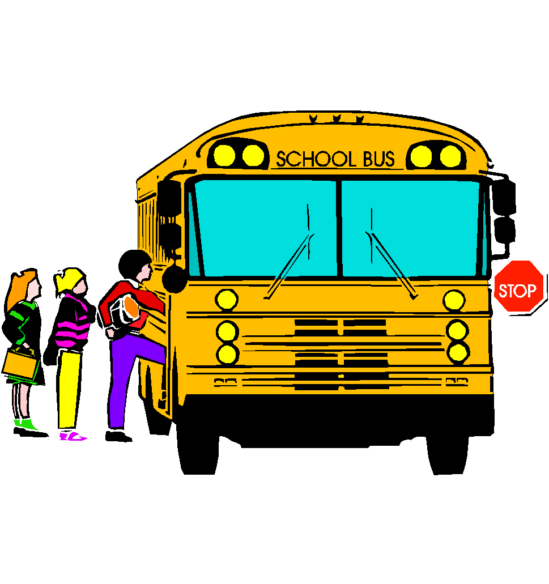

**School Hours**

7:45 a.m. to 2:45 p.m. (Kindergarten through Fifth grade)

7:45 a.m. to 1:00 p.m. (Blended Pre-K)

7:45 a.m. to 1:15 p.m. (Voluntary Pre-K)

**Arrival and Dismissal Procedures**

**It is the parent’s responsibility to ensure the child arrives at school on time**. Knox County Schools Board Policy states, “students who habitually arrive at school at least 15-30 minutes late are considered excessively tardy and are to be referred to the social services worker.” **After 7:45 a.m., accompany your child to the school front entrance to be signed in as tardy, because the school day begins at 7:45 a.m. for students.** Please do not just let your child out and leave them outside the building. A student will be considered ineligible for a perfect attendance award (nine-week grading period) if he/she has accumulated five unexcused tardies during a nine-week grading period, or twenty-five or more unexcused tardies within the year. The doors open at 7:15 a.m. to all students. Please do not drop off students until this time. There is no supervision outside or inside the building. Upon arrival, all students will report to their classrooms.

Buses, preschool, and students with physical needs will drop off and pick up behind the school. All other car riders will drop off and pick up in front of the school. There will be adults supervising and assisting with arrival and dismissal.

If you need to walk your child into the school building, park in the parking lot to the right of the car rider lane. As you exit the parking area, please merge into the car rider line and follow the traffic all the way until you exit. Parents dropping off and or picking up in the car rider line please enter the line in a single file. Please keep the car rider line full by watching the next station that is available as the line moves forward.

Students are dismissed at 2:45 p.m. daily. These students must be picked up by parents or daycare, be transported home by bus, or report to Kid’s Place for after school day care. Students may not be called from classes after 2:30 pm for early dismissal. We use a car tag system where your family members listed will receive a hang tag with a number associated to your child(ren). Anyone picking up a child must verify that they are on the child’s emergency card and present an ID to be added to the “list” to pick up your child. Each family will be allowed to have up to two cards. Additional cards will cost $1.00. If a card is lost, replacement cost will be $1.00.

Students should be picked up no later than 3**:00 p.m**. If you have an emergency, please notify the office.

***After School Care***

We are fortunate to have Kids Place at East Knox County Elementary School for after school day care from 2:45 p.m. until 6:00 p.m. You may call them at 865-660-7230.

***Attendance Policy***

**Attendance is a major factor in determining the academic success of students**. Arriving on time and remaining the entire school day provides students with full academic instruction. Acceptable reasons for being tardy or being dismissed early would include medical or dental appointments (doctors’ excuses required).

State law in Tennessee excuses absences caused by sickness, death in the family, recognized religious holidays, and genuine family emergencies **(documentation required).** A parent is allowed ten days of “parent notes” during the year for absences. A doctor’s excuse is required for all other absences. Please remember how important your child’s attendance is to meet grade level standards.

The Knox County Board of Education requires that excuses indicating the date and reason for an absence be signed by the child’s parent or guardian and given to the child’s teacher **within 5 days of returning to school**. Students who have been absent a total of five days without adequate excuse will receive a letter from Knox County Schools. ParentSquare will send a message if your child is absent.

If your child will be absent for an extended period, please contact your child’s teacher to make arrangements to get their make-up work online, scanned & emailed, or to be picked up in the front office.

***Bullying and Harassment Policy***

Knox County Schools prohibits acts of harassment, intimidation, bullying and cyber-bullying. A safe and courteous environment in school is necessary for students to learn and achieve. Harassment, intimidation or bullying, like other disruptive or violent behaviors, is conduct that disrupts both a student’s ability to learn and a school’s ability to educate students in a safe and orderly environment; and since students learn by example, administrators, faculty, staff, and volunteers should be positive role models in demonstrating appropriate behavior, treating others with civility and respect, and refusing to tolerate harassment, intimidation or bullying. All Knox County Schools teachers and administrative personnel are responsible for ensuring this policy is faithfully implemented in all areas under their purview or direct supervision. **Please see the end of the handbook for the full KCS Board of Education Policy J-211.**

***Bus Safety Guidelines***

In order to ensure students’ safety, all students being transported by bus are under the authority of their bus driver and must obey his/her requests. Knox County Board of Education policy states that the school bus is an extension of school activity; therefore, students shall conduct themselves on the bus in a manner consistent with the established standards for safety and classroom behavior. More specifically, students must follow the official Knox County bus rules.

* Driver is authorized to assign seats.
* No loud, rude, abusive, or profane language.
* No eating or drinking allowed.
* Keep the bus clean.
* Keep hands and head inside the bus.
* Never throw objects inside or out of the bus windows.
* Possession and/or use of tobacco, alcohol, or drugs are prohibited in any form.
* Parents will be financially responsible for any act of vandalism.

**The following rules are posted in a prominent place at the front of the bus.**

* Backs and bottoms on seat
* Keep hands, feet, and belongings to yourself
* Use voice level 2
* Use kind words

The principal shall be informed by the bus driver of any serious discipline problem and may be called upon to assist if necessary. A student may be denied the privilege of riding the bus if the principal determines that his/her behavior is such as to cause disruption on the bus, if he/she endangers the safety of other children, or if he/she disobeys state or local rules and regulations pertaining to student transportation. The suspension of a student from riding the school bus shall follow the same procedures as for any other school suspension.

East Knox provides bus safety training during the first two weeks of school for each bus. We invite the bus driver to be a part of that meeting.

***Cafeteria***

**Please do not bring fast food restaurant lunches into the cafeteria**. Our cafeteria provides nutritious hot lunches daily. Our school is a part of the Community Eligibility Provision, which provides all students in our school breakfast and lunch free of charge. Breakfast is provided daily from 7:15 to 7:45. Monthly menus are available on the KCS school nutrition website at [www.knoxschools.org](http://www.knoxschools.org). No soft drink containers are allowed. All children will be given a number if they wish to purchase an additional milk or ice cream. **If you want to provide the class a treat to celebrate your child’s birthday, we encourage you to buy ice cream for the class. You can call the cafeteria at 865 933 3493 ext. 1 to check availability.**

School meal prices:

**Lunch:**

* Visitors - $4.00
* Extra milk - $0.50, with lunch; $0.75 a la carte
* Ice Cream - $1.00

***Cell Phone Policy***

*According to KCS Board Policy J-240*

Students in grades PK-5 may possess personal communication devices (cell phones) while on school property. However, the PCD **must be in the off mode and must be kept in a backpack,** purse or similar personal carry-all **and may not be used** unless the principal or the principal’s designee grants a student permission to do so.

VIOLATION OF PERSONAL COMMUNICATION DEVICES: A PCD used outside these parameters may result in confiscation of the PCD until it can be released directly to the student's parent or guardian. A student who possesses a PCD, in violation of this policy, is subject to related disciplinary action. Continued violation of this policy may result in loss of PCD privileges. Additionally, students may lose PCD privileges for any policy violation that is related to or is the result of the use of a PCD whether or not the PCD was used within the parameters of this policy.

INAPPROPRIATE USE OF PCD AND/OR ELECTRONIC DEVICES In addition to the parameters established above, use of a PCD or other electronic device to bully, harass or intimidate others will be subject to related disciplinary action. Using a PCD or other electronic device for any illicit activity including but not limited to take, disseminate, transfer, or share obscene, pornographic, lewd, or otherwise illegal images, photographs, or similar material whether by electronic data transfer or otherwise may constitute a crime under State and/or Federal law. **Any student taking**, disseminating, transferring, possessing or sharing obscene, pornographic, lewd, illegal, or otherwise inappropriate images or **photographs of other students or any other individual, particularly underage, at school, on a school bus or while attending any school event or activity will be subject to the disciplinary procedures** of the school district and reported to law enforcement and other appropriate State or Federal agencies.

***Civility Code***

*According to KCS Board Policy B-230*

**EXPECTATIONS**

Students, faculty, staff, parents, guardians, and all other members of the community shall:

1. Treat one another with courtesy and respect at all times.
2. Take responsibility for one’s actions.
3. Be cooperative, to the greatest extent possible, toward one another and in **solving problems based on what is in the best interest of students.**
4. Refrain from behavior that threatens or attempts to disrupt school or school district operations; physically harms someone; intentionally causes damage; employs loud or offensive language, gestures, or profanity; or inappropriately shows a display of temper.

**RESPONSE TO UNCIVIL BEHAVIOR**

The Board does not condone a lack of civility by anyone, and recognizes the following appropriate administrative avenues for aggrieved parties to seek action or redress.

1. A student who believes that he or she has not been treated in a manner reflective of the Code of Civility should report such behavior to the appropriate building level administrator.
2. A parent, guardian or community member who believes that he or she has not been treated in a manner reflective of the Code of Civility should report such behavior to the staff member’s immediate supervisor or the student’s appropriate building level administrator.
3. An employee who believes that he or she has not been treated in a manner reflective of the Code of Civility should address the concern through the appropriate supervisory chain. If personal harm is threatened, the employee shall notify their supervisor and may also contact law enforcement. If a communication such as voice mail or e-mail or any type of written communication is demeaning, abusive, threatening or obscene the employee is not obligated to respond.
4. Any visitor on school district property who has breached this Civility Code may be directed to leave the premises by an administrator or security officer. If such person does not immediately and willingly leave, law enforcement may be called.

***Communication***

Communication to and from school is extremely important and will be provided a variety of ways: mid-term reports and report cards, daily folders, take home folders, newsletters, phone calls, parent conferences, ParentSquare, school website <http://knoxschools.org/eastknoxes>; Twitter @EastKnoxElem, and East Knox Facebook page. It is our goal to keep you informed about the happenings in the classroom and school.

***Crisis Planning***

The safety of your child is our greatest concern. The school holds regular safety drills to teach students to respond calmly in the event of an emergency. Emergency drills are conducted regularly and evacuation plans posted inside each classroom. Each class has an escape route to an outside area and away from the building. Our school crisis plan covers the following potential emergencies: armed intruder, student with firearm, class hostage, arson, bomb threat, disruptive student, missing student, life-threatening crisis, death of a student/staff member, bus accident, fire, and weather-related emergencies. If there was ever an emergency in which students needed to be moved off campus, relocation sites may be 1. Knox County Recreation Dept. Ball Fields behind the staff parking lot (northwest exterior of our school). 2. Roseberry Baptist Church 2920 Roseberry Rd Mascot, TN 37806. 3. Clear Springs Baptist Church 709 Clear Springs Rd Mascot, TN 37806. **It is important that the adult who comes to the reunification site is on the child’s emergency card and the adult brings photo identification.**

***Discipline***

One of the most important lessons education teaches is self-discipline. The purpose of discipline is to teach or change behavior. We have three basic rules of discipline. 1.Be safe. 2. Be respectful. 3. Be responsible. We implement Positive Behavior Intervention Supports at East Knox. Our school-wide expectations are posted through-out our building. Please refer to our School-Wide Expectations matrix below.

PBIS (Positive Behavioral Interventions and Support) is a proactive approach to creating a positive learning climate. At East Knox, our school-wide system of support includes strategies for defining, teaching, and supporting appropriate student behaviors to create a positive school environment. This positive behavior continuum is implemented to make problem behavior less effective, efficient, and relevant, and desired behavior more functional. [www.pbis.org](http://www.pbis.org/)

To encourage positive behavior, East Knox will use a schoolwide point system.  This system will allow multiple opportunities to earn positive incentives such as **brag tags** throughout the day.  Students may also earn positive office referrals.

Teachers will document minor behaviors and submit conduct referrals for the 4th minor or a major behavior. See the flowchart below:

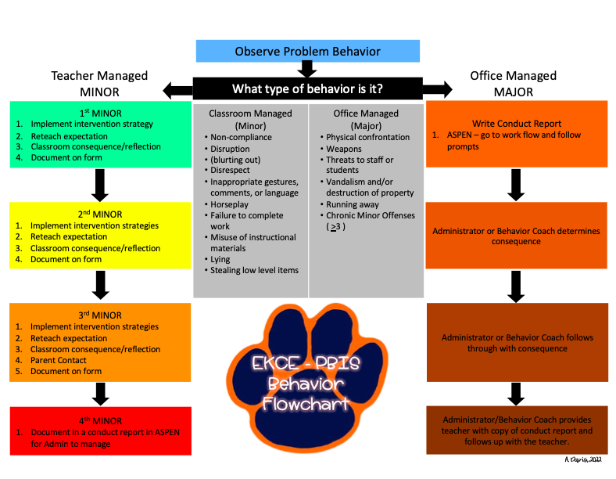

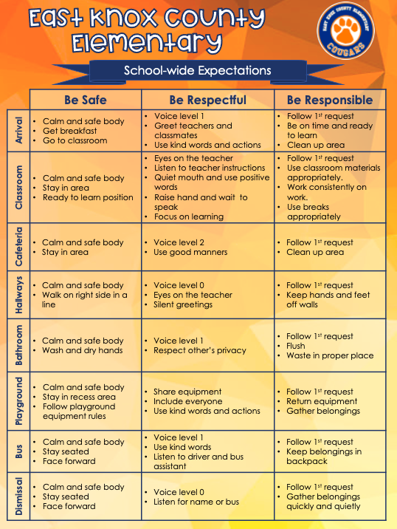

***Dress Code***



The standards for elementary school dress reflect "common sense" and a concern for each child's comfort, safety, cleanliness, and sense of modesty. There is a strong relationship between neat, appropriate attire and a positive learning environment. Apparel or appearance that tends to draw attention to an individual rather than to a learning situation must be avoided. To help create the best learning environment for elementary students, the following standards for student

dress must be observed in all Knox County Elementary Schools **(Board Policy J-260**):

1. Pants must not sag below the waist and must be at a safe length.
2. Head apparel, except for religious or medical reasons, must not be worn inside the school building.
3. Footwear is required and must be safe and appropriate for indoor or outdoor physical activity.
4. Clothing or accessories may not create disruption or display vulgar language or images and must not advertise products which students may not legally purchase.
5. For students in Grades 3-5, "short shorts", mini-skirts, and skin-tight outer materials without proper coverage are inappropriate attire.
6. For students in Grades 3-5, shirts, blouses, and dresses must completely cover the abdomen, back, and shoulders, and shirts or tops must cover the waistband of pants, shorts, or skirts with no midriff visible. Skin-tight outer materials are prohibited without appropriate coverage.

The school administration reserves the right to determine whether the student's attire and appearance are within the acceptable limits. In matters of opinion, the judgment of the principal/designee shall prevail. The principal may allow exceptions for school-wide programs or special classroom activities. The teachers and the principal will administer appropriate consequences for policy infractions.

***Emergency/Safety Information***

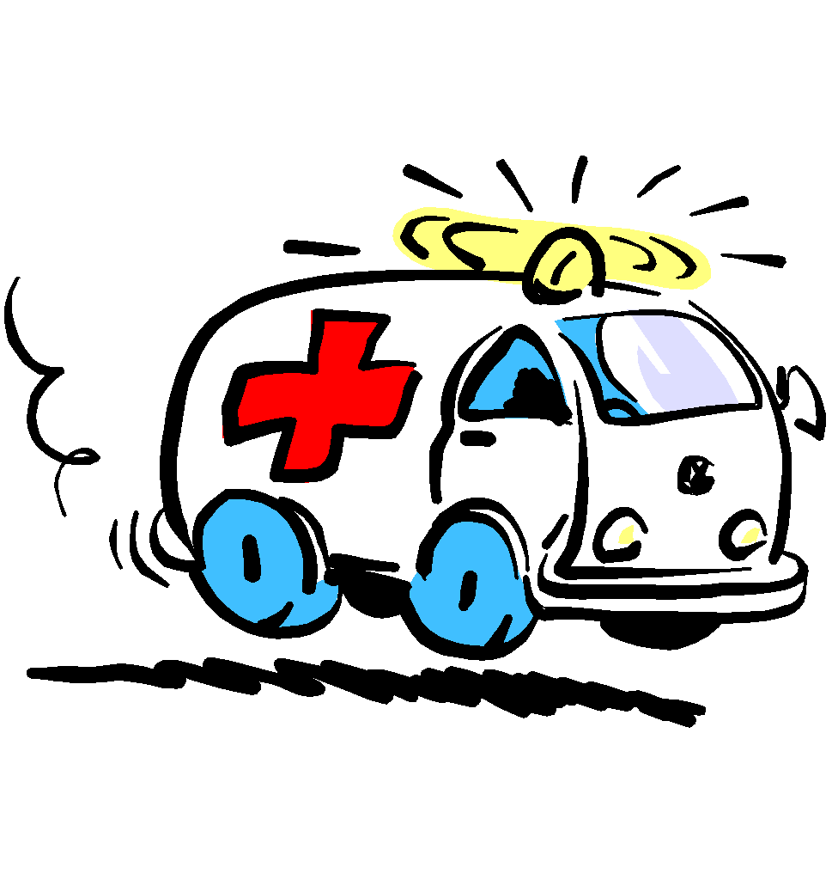

In case of emergency, each student is required to have on file in the office **current** emergency information. This emergency information is our link to you in case of emergency. These are issued to students the first school day and should be returned the next day. It is vital that we always have correct phone numbers for parents, both at home and at work. Neighbors’ or friends’ numbers are also very important so we can act if we are unable to reach you. Please help us by providing several numbers and by keeping them up to date.

A child be released to someone who is not listed on the emergency information sheet. Please, do not ask us to do this by phone or ParentSquare. A FAX will be accepted for another person to pick up your child only in an emergency. If you want to add or delete a person with whom your child can be released, **you must make these changes in person with a valid photo I.D.**  A number system will be used in student loading of cars in the afternoon to further ensure safety. Make sure your child has an issued number for your vehicle in order for pick-up in the afternoons. No child will be released without a number vehicle tag, otherwise you must go into the front office with a valid I.D. If you need a car tag number for your child please check with the office.

Safety is a prime concern at East Knox County Elementary. The school safety plan is updated annually and addresses everyday safety as well as emergencies. All doors in the building will be locked. A buzzer system will be used to allow entrance at the front door. This is to help ensure that strangers do not enter the building. **Do not knock on the back doors of the building for admittance. Everyone but Knox County staff must enter through the front door entrance after being identified.**  East Knox County also has a full-time police officer, Officer Dance.

We ask parents to support our efforts to provide a safe environment by reinforcing school rules with their children regarding behavior at school, and on buses. We require parents to follow safe driving practices around our school and demonstrate good character by conducting themselves in a civil manner. All parents MUST sign in at the office and receive a visitor’s badge. If you do not have a visitor’s badge, we will ask you to get one. This will help keep your child safe by identifying all adults in the building.

***Fees***

A materials’ fee of $25.00 is requested for each student at the time of enrollment. This fee is used to provide classroom materials for instruction. Homeroom teachers will collect these fees. Please make checks payable to East Knox County Elementary School. The fees pay for many expenses, such as, pencils, crayons, folders, notebooks, duplicating paper, art supplies, field trips, and materials for the classroom. The payment of this fee helps us to keep supply lists at a minimum. Please try to pay school fees. If needed, a monthly payment schedule can be created. Thank you for your help.

***Field Trips***

When a field trip is to be taken, your child will bring home a permission slip giving the destination and date. This form must be signed and returned to the teacher by the legal guardian before your child will be allowed to go on the trip. **No child will attend a field trip without a signed permission note.** Every effort should be made to pay for the field trip costs. Children must ride the school bus to the field trip and return to the school on the bus. Parents cannot check children out at the end of a field trip to go home. No child may leave a field trip except for an extreme medical emergency and only with the approval from an administrator.

###### General Guidelines for Acceptable Behavior for Students and Parents

1. Your child is not permitted to bring dangerous or distracting articles to school, such as toys, guns, knives, water guns, lighters, or other similar articles.
2. Instruct your child in stranger safety.
3. Tobacco products are not allowed in the building, playground, or on buses.
4. Students are to stay on the playground or the designated area for play.
5. Appropriate language should be used at all times.
6. Chewing gum is not allowed in the school without special permission from the teacher.
7. Glass containers are not to be brought to school.
8. Soda or soft drinks are not allowed. Parents may eat lunch with their child.
9. Appropriate behavior is required in the restrooms.
10. Students are to remain with their teacher. Do not leave the classroom without permission.
11. Students are expected to behave in a respectful manner to all school personnel, and follow the first request.
12. Parents may be responsible to pay for damages, if their child destroys of school property.
13. Running in the hallways, pushing, shoving, yelling, and slamming doors is **not** acceptable behavior.
14. Fighting is not tolerated and may result in suspension.

***Illness***

Our school is fortunate do have a full-time nurse. If a student becomes too ill to remain in class, they will be sent to the clinic, and the nurse will call for someone to pick up your child. This is why it is so important that we have an **updated, working phone number(s) on the emergency card to reach you**. If your child has vomited before school or is running a fever, please keep him or her at home. A child must be fever and vomit free for 24 hours before returning to school.

***Instruction Time***

Instructional time will be protected. If you need to get a message to your child or your child’s teacher, you may do so through the office. While teachers want to be available to you, their first priority is teaching during the school day. Your child needs and deserves uninterrupted learning time.

***Media Releases for Students***

Student Media Release Form (Form PA-100) should be signed by parents/guardians for all students on campus. Any student who does not have a signed Media Release Form on file will be unable to participate in media opportunities, interviews, or videos by either external newsgroups or Central Office.

***Chromebook Information***

Knox County Schools is a 1-1 district, meaning students are issued a device for learning. For students who will be taking their Chromebooks home, it is important to charge the Chromebooks at home, and bring them to school each day. To be able to take the Chromebook home, all students will need to have a family member sign a KCS Device agreement.

Knox County Schools has a damage policy for Chromebooks. It is important to note that any intentional damage will not be covered by the insurance. This will include:

* Food or drink that has spilled in between the keys or on the screen
* Markings of any kind on the inside or outside of the Chromebook
* Stickers on the inside or outside of the Chromebook

These are some of the more common issues. KCS says that personalization of any kind will be considered intentional damage, and could result in a fee. There are plastic cases that can be purchased on Amazon. If you would like to protect the device or personalize it, this is a good option.

If you would like to have insurance for the Chromebook, you will need to complete the payment form.

Link to the insurance (be sure to sign in)-[https://knoxschools.schoolcashonline.com/Fee/Details/14642/231/False/True](https://nam11.safelinks.protection.outlook.com/?url=https%3A%2F%2Fknoxschools.schoolcashonline.com%2FFee%2FDetails%2F14642%2F231%2FFalse%2FTrue&data=04%7C01%7Ccyndee.casselman%40knoxschools.org%7Ca2d1c3d1b5354c65ae2008d95e4896ba%7Ca2c165ce3db24317b7428b26460ec108%7C0%7C0%7C637644488113048838%7CUnknown%7CTWFpbGZsb3d8eyJWIjoiMC4wLjAwMDAiLCJQIjoiV2luMzIiLCJBTiI6Ik1haWwiLCJXVCI6Mn0%3D%7C1000&sdata=QvGV%2Bw7nM6iTOi6vxBjIfKQHKokLS73HUzd83%2Fa%2Bwxg%3D&reserved=0)

***Parents Tips to prevent Cyberbullying***

*U.S. Department of Education*

1.Increase awareness: Help ensure younger children know the basics of staying safe online by using techniques like online games and videos that will define computer terms (e.g., cyberbullying, netiquette, virus protection) to establish basic understanding.

2. Protect your kid’s identity: Remind your kids never to give out personal information, such as name, home address, or telephone number, to anyone they don’t know through email, Twitter, Facebook, or in online chat rooms or bulletin boards. Talk with your children about the online risks of interacting with strangers through the computer and sending notes and picture

3. Protect your computer: Regularly updating security software can protect your family against scammers, hackers, and other online threats that can compromise your computer system and, consequently, your family’s financial security and other private information. Using software security that automatically updates keeps your technology current and decreases the likelihood of picking up bad programs or malware.

4. Create unique passwords: For online safety, tell your kids to use different passwords for every online account they have to help prevent others from accessing their personal information. Make sure that you monitor each account and make sure your children know that strong passwords should include elements like symbols, numbers, uppercase and lowercase letters, and no names or words that others could easily guess.

5. Monitor online activity: Monitoring your kids’ online activity can help keep them safe. Explore various parental controls and consider what options may work best for you and your family.

6. Prevent cyberbullying: Cyberbullying—bullying using electronic technology—can happen anytime and anywhere. Teach your children to think through what they post on the Net about other people and the consequences those posts could have if they are unkind or mean. Also, keep communication with your child open and speak up if you suspect someone is bullying him or her.

7. Promote appropriate online interactions: Use some online games to help show kids how to make responsible decisions about online communication and learn about key issues of digital citizenship.

***Medication Policy***

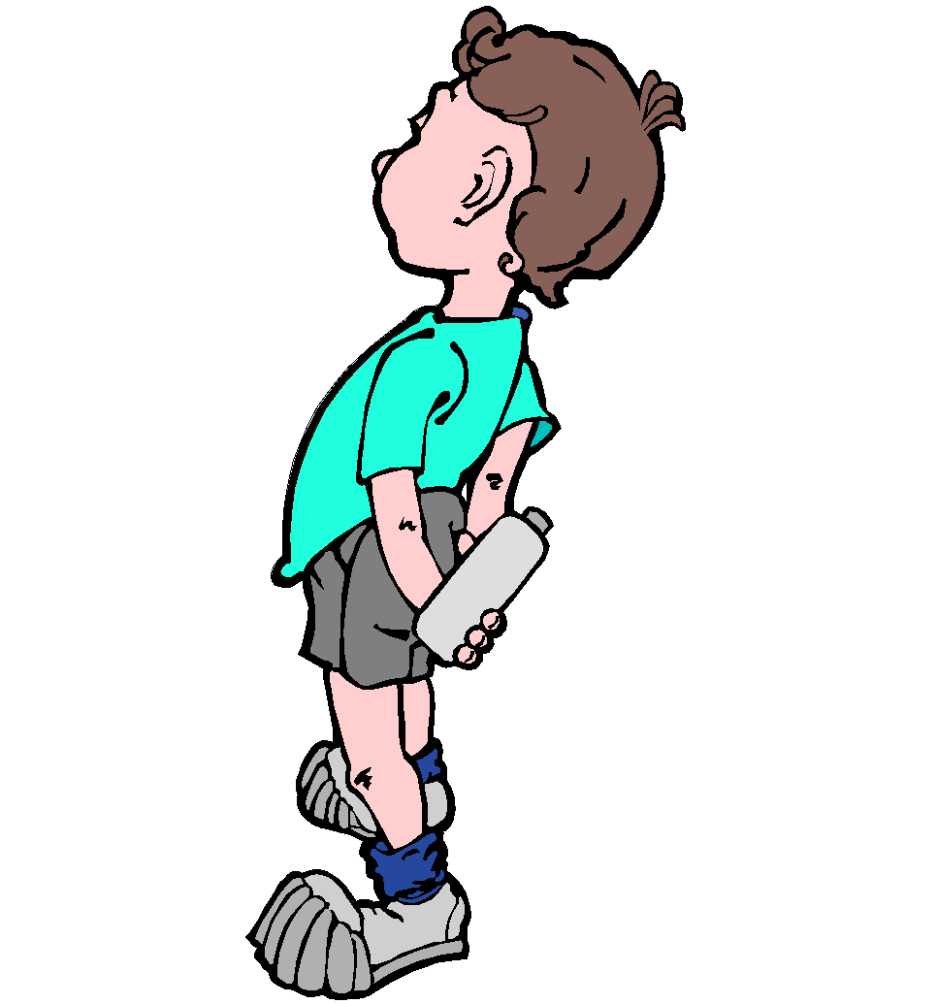

If it becomes necessary for a student to take any form of medication at school, a medical form signed by a doctor must be presented to the office. These forms may be picked up in the nurse’s office. All medication will be kept in a locked box in the nurse’s office and is dispensed by the nurse.

Prescriptions or over-the-counter medicine are never to be sent to school with a student. For temporary illnesses, the parents must fill out the medical form issued by the school nurse and completed by the child’s doctor for medicine to be administered at school. The form and medication should be delivered to the office by the parent. The medicine will then be given to the nurse to keep in a locked box.

***Personal Property***

The school is not responsible for any loss or damage of personal property. Personal belongings should be clearly marked with the student’s name. Lost items are usually placed on the lost and found rack located in the hall beyond the cafeteria. Due to the volume of lost items collected in the past, we cannot store them for an indefinite period. Therefore, at the end of each semester, all unclaimed items will be donated to charity.

Please do not send toys or valuables to school with your child. **If you choose to send a cellular phone to school with your child, it must remain turned off and stored in his/her backpack at all times.** If the child has the phone displayed during school, the phone will be removed, kept in the office and parents will be notified to pick up the phone.

***School Closing Due to Inclement Weather***

Decisions to close school because of inclement weather or disaster are made by the Knox County School System. Please do not call school to find out if school is to be closed or dismissed early due to snow, ice, or other disasters. A school message will be sent by Knox County School as soon as the decisions are made. Calling the school “jams” the phone lines and slows dismissal.

***Smoking/Tobacco/Alcohol/Drug Use Policy***

Smoking and the use of tobacco products are prohibited on all school property. Alcohol and other drug use is prohibited among all students, school staff members, and visitors.

***Student Transfer***

If a student transfers to another school, parents should notify the teacher or the secretary in advance if possible. Students should not leave with debts to the school. Library books and textbooks must be returned before leaving, and before records can be released.

*Transfer Option for Students Victimized by Violent Crime at School Under the Tennessee State Board of Education’s Unsafe School Choice Policy, any public-school student who is the victim of a violent crime as defined under Tennessee Code Annotated 40-38-111 (g), or the attempt to commit one of these offenses as defined under Tennessee Code Annotated 39-12-101, shall be provided an opportunity to transfer to another grade- level appropriate school within the district. Additional information regarding this option may be obtained by contacting Brian Hartsell, Supervisor of Transfers at 865-594-1502.

***Visiting/Volunteering in our School***

**All visitors or volunteers, upon entrance into the building, are required to report to the office. If you have a scheduled appointment, a visitor’s badge will be given to you, then the front office will give you directions for what to do next.**

VOLUNTEERING: We encourage parents to help a teacher when help is requested. Visits should be one hour or less, unless the teacher is doing a special project and he/she has arranged with the parent for an extended visit. Parents should check into the office, office staff will confirm their visit, and they will sign in the volunteer book, and **receive a badge** before going to the teacher’s room.

VISITS: If you wish to visit your child’s classroom, call the office and a time will be arranged. Visits will be limited to one hour unless you are helping with projects or activities at the request of the teacher. Teachers and students work on a carefully planned schedule to ensure maximum time daily be devoted to student learning. If you would like to speak to a teacher concerning an emergency or special need, please call the office and Ms. Theresa or Ms. Jackie will check to see when he/she will be available to speak with you. Please do not try to discuss problems with teachers during 7:15-7:45 a.m. since it is a busy and crucial time to set the tone for each school day and other students are present. Any changes in a child’s dismissal should be sent to the teacher in a written note so there will be no confusion about the changes. **We cannot take a child’s verbal statement to make changes. Notification must be done in writing and sent to the teacher.**

EATING LUNCH with your CHILD: **Only people listed on the student’s emergency card are allowed to eat lunch with students.** Please sign in, be prepared to show your ID, and meet them in the lobby on their way to lunch. Contact your child’s teacher for their lunch time. **Due to Federal Guidelines concerning our lunch program, please do not bring outside food into our school cafeteria.**

**Addendum:**

**KCS Board Policy J-211. Harassment, Intimidation, and Cyber-bullying**

**GENERAL**

Knox County Schools prohibits acts of harassment, intimidation, bullying and cyber-bullying. A safe and courteous environment in school is necessary for students to learn and achieve. Harassment, intimidation or bullying, like other disruptive or violent behaviors, is conduct that disrupts both a student’s ability to learn and a school’s ability to educate students in a safe and orderly environment; and since students learn by example, administrators, faculty, staff, and volunteers should be positive role models in demonstrating appropriate behavior, treating others with civility and respect, and refusing to tolerate harassment, intimidation or bullying. All Knox County Schools teachers and administrative personnel are responsible for ensuring this policy is faithfully implemented in all areas under their purview or direct supervision.

**“Cyber-bullying”** means bullying undertaken through the use of electronic devices;

**“Electronic devices”** include, but are not limited to, telephones, cellular phones or other wireless telecommunication devices, personal digital assistants (PDAs), computers, electronic mail, instant messaging, text messaging, and web sites;

**“Harassment, intimidation or bullying”** means any act that substantially interferes with a student’s educational benefits, opportunities, or performance; and:

(A) If the act takes place on school grounds, at any school-sponsored activity, on school-provided equipment or transportation or at any official school bus stop, the act has the effect of:

(i)  Physically harming a student or damaging a student’s property:

(ii)  Knowingly placing a student or students in reasonable fear of physical harm to the student or damage to the student’s property;

(iii)  Causing emotional distress to a student or students; or

(iv)  Creating a hostile educational environment; or

(B) If the act takes place off school property or outside of a school-sponsored activity, it is directed specifically at a student or students and has the effect of creating a hostile educational environment or otherwise creating a substantial disruption to the education environment or learning process.

All students are expected to refrain from acts of harassment, intimidation and bullying or cyber-bullying in any form and to be aware that such disciplinary measures as are appropriately assigned in Board Policy J-191 will be utilized for the unacceptable behavior described above.

**PREVENTION AND TRAINING**

At the beginning of each school year, principals will provide this policy to parents and ensure that students are aware of the expectations for their behavior under this policy. This policy shall also be posted in the Board of Education policy page of the Knox County Schools website.

To promote and foster intergroup awareness, appreciation and understanding by students of the diverse ethnic, racial, and cultural groups represented in the school district, United States, and the world, the Knox County Schools shall:

* Provide on-going professional development to prevent harassment, intimidation, and bullying.
* Implement practices to achieve safer and less violent schools for students, teachers, and administrators.
* Endeavor to ensure that the curriculum does not promote stereotypical views of any group and recognizes the accomplishments and contributions of all peoples.

**REPORTING AND RESPONSE**

Students who feel they are being harassed, bullied, or intimidated may report this concern to any teacher, or school administrator or the office of the Superintendent using any means of communication with which they feel comfortable. Students may report anonymously, and anonymous reports will be treated with the same level of urgency as all other reports.

All school employees are required to report alleged violations of this policy to the principal or the principal’s designee for investigation and appropriate action. Submission of a written incident report to the principal is required by all district employees. Oral reports will also be considered official reports. Reports may be made anonymously, but formal disciplinary action may not be based solely on the basis of an anonymous report. Once a report is received, the principal or his or her designee must initiate an investigation with forty-eight (48) hours unless the need for additional time is appropriately documented. An appropriate intervention must be initiated within twenty (20) calendar days from the receipt of the report unless the need for more time is appropriately documented. Parents must be immediately informed if their student is involved in an act of harassment, intimidation, bullying or cyber-bullying.

A school employee, student or volunteer who possesses reliable information that a student has electronically transmitted a credible threat to cause bodily injury or death to another student or school employee shall report such information to the Principal or other school administrator. The Principal shall, in consultation with the appropriate district administrative personnel, make a determination regarding the disposition of the report with respect to appropriate investigations and disciplinary actions.

Failure to report reliable information about an electronically transmitted credible threat to a student or employee may result in disciplinary action for the student or employee withholding the information. If a volunteer fails to report such information, the volunteer may be restricted from volunteering at any further school related activities.

A school employee, student or volunteer may not engage in reprisal or retaliation against a victim of, witness to, or person with reliable information about an act of harassment, intimidation, bullying or cyber- bullying.

No student shall be the subject of reprisal for any report of bullying, harassment, and intimidation. Students found to have perpetrated acts of reprisal shall be subject to appropriate disciplinary action as described in Board Policy J-191.4.

Consequences for a student found to have falsely accused another as a means of harassment, intimidation, or bullying range from behavioral interventions up to and including suspension or expulsion, as permitted under Board Policy J-191.

The following factors will be considered in determining the appropriate response to students who commit one or more acts of harassment, intimidation, bullying or cyber-bullying:

1. The developmental level and maturity levels of the parties involved;
2. The levels of harm as determined by the student’s ability to be educated in a safe and orderly environment;
3. The surrounding circumstances;
4. The nature of the behavior(s);
5. Past incidences or continuing patterns of behavior;
6. The relationships between the parties involved; and
7. The context in which the alleged incidents occurred.

Consequences and appropriate remedial action for students who commit acts of harassment, intimidation, or bullying may range from behavioral interventions up to and including suspension or expulsion. The appropriate action will be consistent with established Board policy, case law, and federal and state statutes.